Networks and Markets

Hw1 submission  
Part 3

Alon Polsky 206530461

10.

(b) The average seems to be around 3.7. It's not that surprising based on the Milgram experiment, and that the probability that the distance between every two nodes is greater than 2 converges to zero when grows to infinity in a random graph.  
(c) We computed the exact probability by iterating through all possible pairs of nodes, checking if there's a connecting edge between the nodes in every pair and dividing the total number of pairs with a connecting edge by the total number of pairs.  
The probability is 0.011.  
(d) Our measurements show the average shortest path length of the Facebook data is greater than it would be for a random graph with the same number of nodes and value of (which is around 2.68).  
We believe this is the case because people don't behave as nodes in a random graph but are more likely to form large cliques and every two such clique tend to have a connecting edge or a mutual node. So while people are not as connected to the rest of the world as nodes in a random graph, as a whole they are still not that far from being as connected as a random graph, so their average distance is the average distance of a random graph plus the little overhead you get for moving to the right node in every clique you go through.

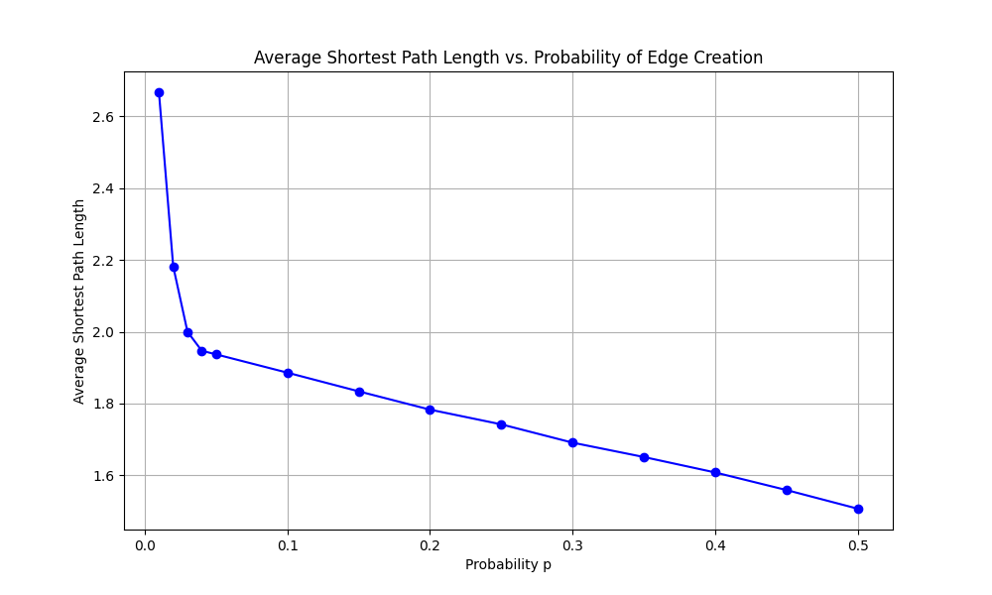

The measurements we got from running part (9d)'s experiment  
on a graph with 4039 nodes.